Using Null

1. select name from teacher where dept is null

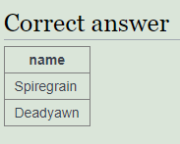

1. SELECT teacher.name, dept.name FROM teacher INNER JOIN dept ON (teacher.dept=dept.id)

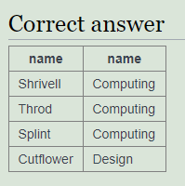

1. SELECT teacher.name, dept.name FROM teacher LEFT JOIN dept ON (teacher.dept=dept.id)

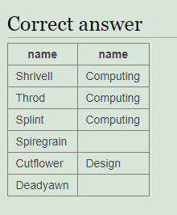

1. SELECT teacher.name, dept.name FROM teacher RIGHT JOIN dept ON (teacher.dept=dept.id)

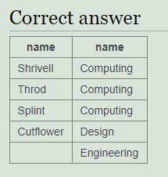

1. select name, COALESCE(mobile,'07986 444 2266') from teacher

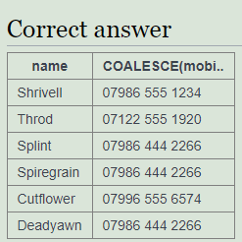

1. select teacher.name, COALESCE(dept.name,'None') from teacher LEFT JOIN dept on (teacher.dept = dept.id)

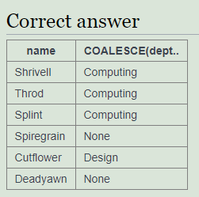

1. select count(\*), count(mobile) from teacher

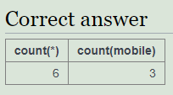

1. select dept.name,count(teacher.name) from teacher RIGHT JOIN dept on (dept = dept.id) group by dept.name

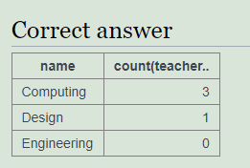

1. select name, CASE WHEN dept in (1,2) THEN 'Sci' ELSE 'Art' END from teacher

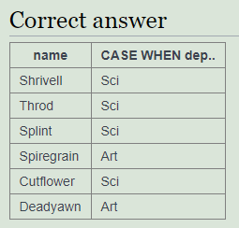

1. select name, CASE WHEN dept in (1,2) THEN 'Sci' WHEN dept in (3) THEN 'Art' ELSE 'None' END from teacher

